Backtracking Exercises
Ibrahim Albluwi

Exercise 1

Given a set of N coins C = {c1, c2, c3, ..., cN} and a monetary value M > 0, find the smallest subset of C that can pay value K (without change).

Note that in this problem, C can have duplicates, and a coin can be used only once.

Examples. C = {1, 1, 4, 20, 20, 21, 25, 40}

M = 45 Answer = {20, 25}
M = 132 Answer = {1, 1, 4, 20, 20, 21, 25, 40}
M = 3 Answer = No subset meets the requirements

Design a backtracking algorithm to solve this problem. Follow the steps below:

A. Draw a tree showing how a brute-force enumeration algorithm enumerates the solutions for the following instance: C = {2, 2, 4} M = 4.

Clearly show on the tree what each node and edge represents and which solutions are feasible and which are not.

B. Suggest a backtracking strategy to improve the running time of the brute-force algorithm.

C. Provide an example of values for C {at least 4} and M that will lead to:

1. No pruning in the tree.

2. Maximum pruning in the tree.

Exercise 2

Consider the following problem:

MAX-CLIQUE. Given a directed graph G, find the size of the largest subset S of the vertices in G, such that all the vertices in S are adjacent (S is called a max-clique).

Examples.

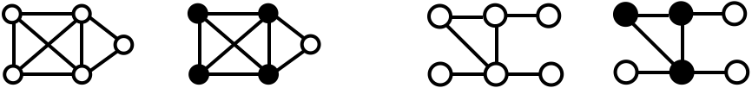
G The MAX-CLIQUE G The MAX-CLIQUE
is of size 4 is of size 3

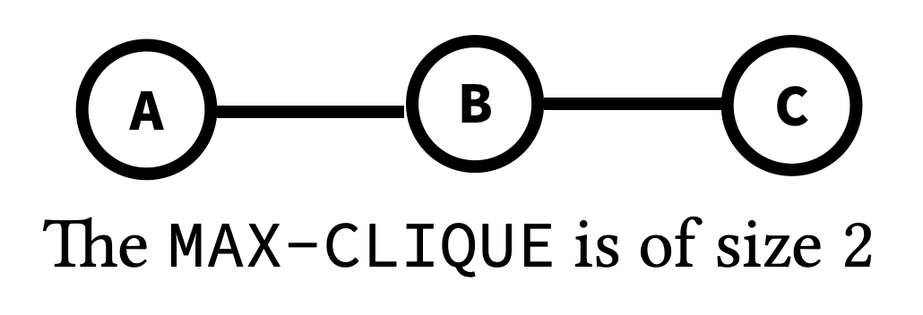
A. Draw a (large and clear) tree showing how a brute force algorithm enumerates all the possible solutions for the graph given on the right.

Make sure to clearly indicate:
- What each edge in the tree represents.
- Feasible candidate solutions.
- Infeasible candidate solutions.

B. What is the running time of the brute force algorithm? Express your answer using V (the number of vertices in G) and use Big-Theta notation.

C. Suggest a backtracking strategy for improving the running time of the brute force solution.

Exercise 3
You are given an array of N price changes for an item in some market. At each price change, you can buy the item, sell the item (if you already have it), or not do anything. Your goal is to make decisions that maximize your overall profit.
0 1 2 3 4 5
Example. prices = [1, 3, 2, 8, 4, 9] Output = 12
Explanation.
The maximum profit can be achieved by:
- Buying at prices[0] = -1
- Skipping prices[1] and prices[2]
- Selling at prices[3] = +8
- Buying at prices[4] = -4
- Selling at prices[5] = +9
The total profit is -1 + 8 - 4 + 9 = 12.
Design a backtracking algorithm to solve this problem. Follow the steps below:
A. Draw a tree showing how a brute-force enumeration algorithm enumerates the candidate solutions for the following instance: prices = [1, 3, 2]
Clearly show on the tree what each node and edge represent. You don’t have to draw the full tree as it might be large. However, you must show the root, the second level in the tree, and the full path to at least two feasible solutions and two infeasible solutions.

B. Suggest a backtracking strategy to improve the running time of the brute-force algorithm.

